
Sarhad College of Arts, Commerce &

Science Katraj Pune-46
NAAC Accredited with B+ Grade
(FACULTY OF SCIENCE & TECHNOLOGY)

Subject: CA 511 MJP : Lab Course based on CA 510A MJ

Name of the Student -………………………………………..

Roll No-……………… Exam Seat No……………………….


SARHAD COLLEGE OF ARTS, COMMERCE AND SCIENCE KATRAJ, PUNE-46 (FACULTY OF SCIENCE & TECHNOLOGY)
Seat No:-

CERTIFICATE

This is informed that Miss /Mr/Mrs. ___________________ Roll No. ___________ From _____________ class has satisfactorily completed the laboratory course in ________ subject during the year __________ as per the requirement of the university of Pune.
Date:-

Teacher In-charge HOD Principal

Internal Examiner External Examiner

INDEX
Sr. No. | Title | Page No. | Date | Sign
1 | Assignment 1 | 5
2 | Assignment 2 | 7
3 | Assignment 3 | 9
4 | Assignment 4 | 11
5 | Assignment 5 | 13
6 | Assignment 6 | 15
7 | Assignment 7 | 27
8 | Assignment 8 | 30
9 | Assignment 9 | 34
10 | Assignment 10 | 38

UNIT – I : Introduction of Java
Q1: Multiplication Table
Question: Write a Java program to accept a number from user and generate multiplication table of a number. Accept number using Buffered Reader class.
Code:-
import java.io.*;

public class Ass1 {
public static void main(String[] args) throws IOException {
BufferedReader br = new BufferedReader(new InputStreamReader(System.in));

System.out.print("Enter a number: ");
int num = Integer.parseInt(br.readLine());

System.out.println("\nMultiplication Table of " + num + ":");
System.out.println("================================");

for(int i = 1; i <= 10; i++) {
System.out.println(num + " x " + i + " = " + (num * i));
}
}
}
Output:-
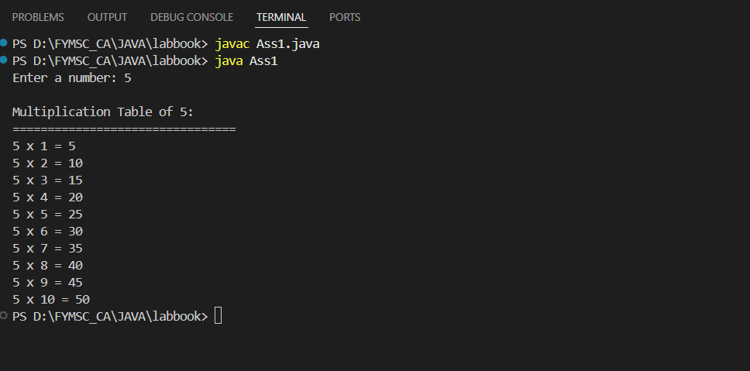

Q2: Prime Numbers
Question: Write a Java program to accept a number from user and print all prime numbers up to that number (Use Buffered Reader class).
Code:-
import java.io.*;

public class Ass2 {
public static void main(String[] args) throws IOException {
BufferedReader br = new BufferedReader(new InputStreamReader(System.in));

System.out.print("Enter a number: ");
int n = Integer.parseInt(br.readLine());

System.out.println("\nPrime numbers up to " + n + ":");
System.out.println("================================");

for(int i = 2; i <= n; i++) {
if(isPrime(i)) {
System.out.print(i + " ");
}
}
System.out.println();
}

static boolean isPrime(int num) {
if(num <= 1) return false;
for(int i = 2; i <= Math.sqrt(num); i++) {
if(num % i == 0) return false;
}
return true;
}
}
Code:-
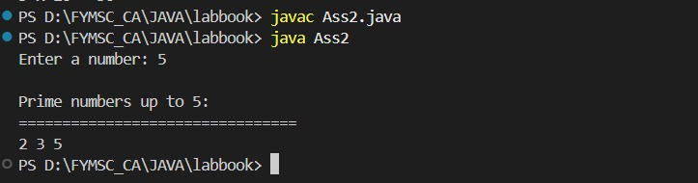

Q3: Armstrong Numbers
Question: Write a Java Program to Display Armstrong Numbers Between range. Accept range from user.
Code:-
import java.util.Scanner;

public class Ass3 {
public static void main(String[] args) {
Scanner sc = new Scanner(System.in);

System.out.print("Enter start of range: ");
int start = sc.nextInt();
System.out.print("Enter end of range: ");
int end = sc.nextInt();

System.out.println("\nArmstrong numbers between " + start + " and " + end + ":");
System.out.println("================================================");

for(int i = start; i <= end; i++) {
if(isArmstrong(i)) {
System.out.print(i + " ");
}
}
System.out.println();
}

static boolean isArmstrong(int num) {
int original = num, sum = 0, digits = 0;
int temp = num;

// Count digits
while(temp != 0) {
digits++;
temp /= 10;
}

temp = num;
// Calculate sum of powers
while(temp != 0) {
int digit = temp % 10;
sum += Math.pow(digit, digits);
temp /= 10;
}

return sum == original;
}
}
Output:-
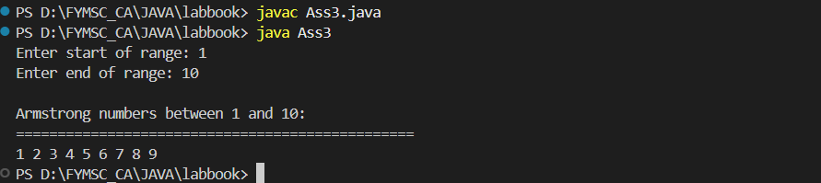

Q4: Matrix Multiplication
Question: Write Java program to find multiplication of two matrix. Accept matrix from user.
Code:-
import java.util.Scanner;

public class Ass4 {
public static void main(String[] args) {
Scanner sc = new Scanner(System.in);

System.out.print("Enter rows of first matrix: ");
int r1 = sc.nextInt();
System.out.print("Enter columns of first matrix: ");
int c1 = sc.nextInt();

System.out.print("Enter rows of second matrix: ");
int r2 = sc.nextInt();
System.out.print("Enter columns of second matrix: ");
int c2 = sc.nextInt();

if(c1 != r2) {
System.out.println("Matrix multiplication not possible!");
System.out.println("Columns of first matrix must equal rows of second matrix.");
return;
}

int[][] mat1 = new int[r1][c1];
int[][] mat2 = new int[r2][c2];
int[][] result = new int[r1][c2];

System.out.println("\nEnter elements of first matrix:");
for(int i = 0; i < r1; i++) {
for(int j = 0; j < c1; j++) {
System.out.print("Element [" + i + "][" + j + "]: ");
mat1[i][j] = sc.nextInt();
}
}

System.out.println("\nEnter elements of second matrix:");
for(int i = 0; i < r2; i++) {
for(int j = 0; j < c2; j++) {
System.out.print("Element [" + i + "][" + j + "]: ");
mat2[i][j] = sc.nextInt();
}
}

// Matrix Multiplication
for(int i = 0; i < r1; i++) {
for(int j = 0; j < c2; j++) {
result[i][j] = 0;
for(int k = 0; k < c1; k++) {
result[i][j] += mat1[i][k] * mat2[k][j];
}
}
}

// Display matrices
System.out.println("\nFirst Matrix:");
displayMatrix(mat1, r1, c1);

System.out.println("\nSecond Matrix:");
displayMatrix(mat2, r2, c2);

System.out.println("\nResultant Matrix:");
displayMatrix(result, r1, c2);
}

static void displayMatrix(int[][] mat, int rows, int cols) {
for(int i = 0; i < rows; i++) {
for(int j = 0; j < cols; j++) {
System.out.print(mat[i][j] + "\t");
}
System.out.println();
}
}
}
Output:-
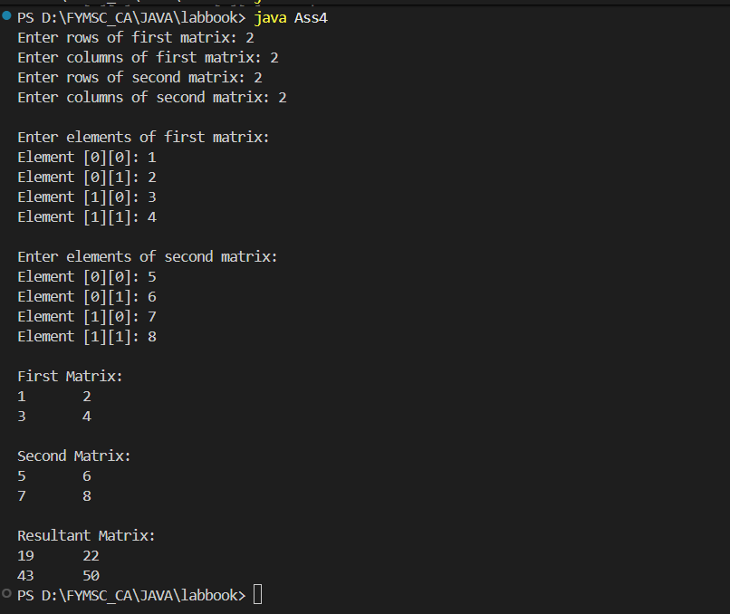

UNIT II: Classes and Objects
Ass5: Student Class
Question: Define a class student having rollno, name and percentage. Define Default and parameterized constructor. Accept the 5 student details and display it. (Use this keyword).
Filename: Ass5.java
java
import java.util.Scanner;

class Student {
int rollno;
String name;
float percentage;

// Default constructor
Student() {
this.rollno = 0;
this.name = "";
this.percentage = 0.0f;
}

// Parameterized constructor
Student(int rollno, String name, float percentage) {
this.rollno = rollno;
this.name = name;
this.percentage = percentage;
}

void display() {
System.out.println("Roll No: " + this.rollno);
System.out.println("Name: " + this.name);
System.out.println("Percentage: " + this.percentage + "%");
System.out.println("-----------------------------");
}
}

public class Ass5 {
public static void main(String[] args) {
Scanner sc = new Scanner(System.in);
Student[] students = new Student[5];

System.out.println("Enter details for 5 students:");
System.out.println("=============================\n");

for(int i = 0; i < 5; i++) {
System.out.println("Student " + (i+1) + ":");
System.out.print("Roll No: ");
int rollno = sc.nextInt();
sc.nextLine(); // consume newline
System.out.print("Name: ");
String name = sc.nextLine();
System.out.print("Percentage: ");
float percentage = sc.nextFloat();

students[i] = new Student(rollno, name, percentage);
System.out.println();
}

System.out.println("\n*** Student Details ***\n");
for(int i = 0; i < 5; i++) {
students[i].display();
}
}
}
Output:-
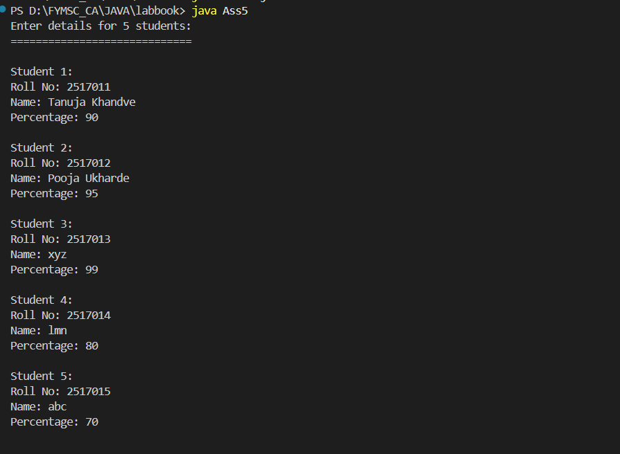
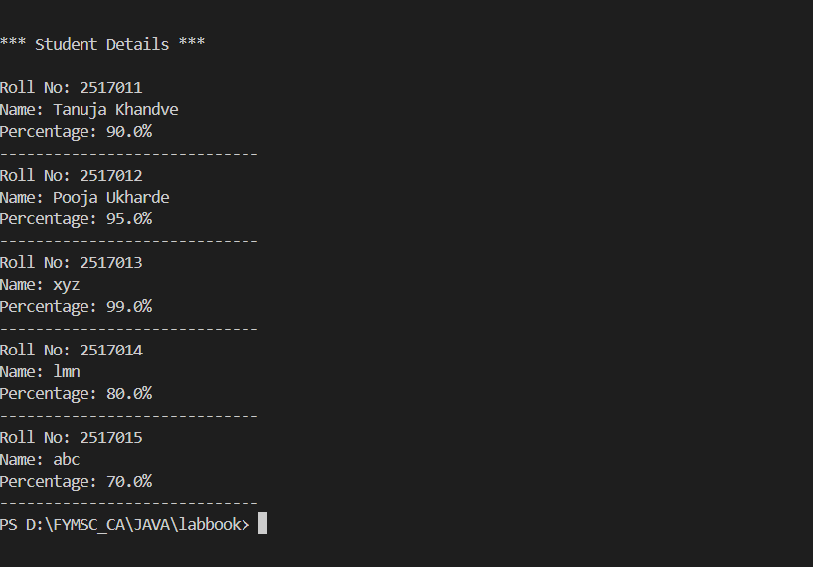

Ass6: MyDate Class
Question: Write a program create class as MyDate with dd,mm,yy as data members. Write parameterized constructor. Display the date in dd-mm-yy format. (Use this keyword).
Filename: Ass6.java
java
import java.util.Scanner;

class MyDate {
int dd, mm, yy;

// Parameterized constructor
MyDate(int dd, int mm, int yy) {
this.dd = dd;
this.mm = mm;
this.yy = yy;
}

void display() {
System.out.println("Date: " + this.dd + "-" + this.mm + "-" + this.yy);
}
}

public class Ass6 {
public static void main(String[] args) {
Scanner sc = new Scanner(System.in);

System.out.println("Enter date details:");
System.out.println("===================");
System.out.print("Enter day: ");
int dd = sc.nextInt();
System.out.print("Enter month: ");
int mm = sc.nextInt();
System.out.print("Enter year: ");
int yy = sc.nextInt();

MyDate date = new MyDate(dd, mm, yy);

System.out.println("\nDate in dd-mm-yy format:");
date.display();
}
}
Output:-
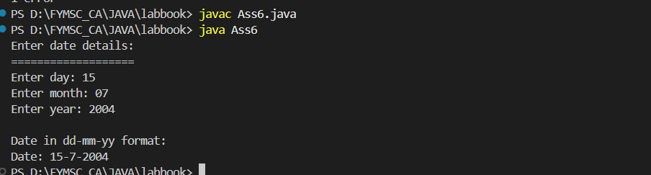

Ass7: Account Class with Sorting
Question: Write a program to create class Account (accno, accname, balance). Create an array of 'n' Account objects. Define static method "sortAccount" which sorts the array on the basis of balance. Display account details in sorted order.
Filename: Ass7.java
java
import java.util.Scanner;

class Account {
int accno;
String accname;
double balance;

Account(int accno, String accname, double balance) {
this.accno = accno;
this.accname = accname;
this.balance = balance;
}

static void sortAccount(Account[] accounts) {
// Bubble sort based on balance
for(int i = 0; i < accounts.length - 1; i++) {
for(int j = 0; j < accounts.length - i - 1; j++) {
if(accounts[j].balance > accounts[j+1].balance) {
Account temp = accounts[j];
accounts[j] = accounts[j+1];
accounts[j+1] = temp;
}
}
}
}

void display() {
System.out.println("Account No: " + accno);
System.out.println("Account Name: " + accname);
System.out.println("Balance: Rs." + balance);
System.out.println("-----------------------------");
}
}

public class Ass7 {
public static void main(String[] args) {
Scanner sc = new Scanner(System.in);

System.out.print("Enter number of accounts: ");
int n = sc.nextInt();
Account[] accounts = new Account[n];

System.out.println("\nEnter account details:");
System.out.println("======================");

for(int i = 0; i < n; i++) {
System.out.println("\nAccount " + (i+1) + ":");
System.out.print("Account No: ");
int accno = sc.nextInt();
sc.nextLine();
System.out.print("Account Name: ");
String accname = sc.nextLine();
System.out.print("Balance: ");
double balance = sc.nextDouble();

accounts[i] = new Account(accno, accname, balance);
}

// Sort accounts by balance
Account.sortAccount(accounts);

System.out.println("\n*** Account Details (Sorted by Balance) ***\n");
for(int i = 0; i < n; i++) {
accounts[i].display();
}
}
}
Output:-
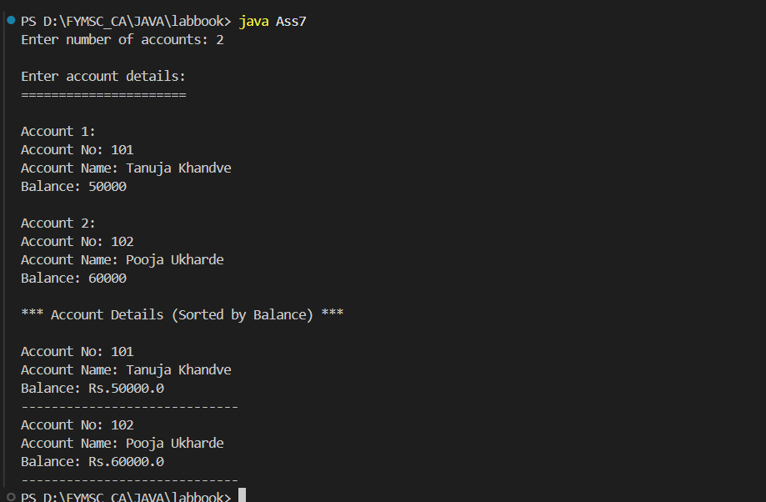
Ass8: Employee Maximum Salary
Question: Write a program which define class Employee with data member as id, name and salary Store the information of 'n' employees and display the name of employee having maximum salary (Use array of object).
Filename: Ass8.java
java
import java.util.Scanner;

class Employee {
int id;
String name;
double salary;

Employee(int id, String name, double salary) {
this.id = id;
this.name = name;
this.salary = salary;
}

void display() {
System.out.println("ID: " + id + ", Name: " + name + ", Salary: Rs." + salary);
}
}

public class Ass8 {
public static void main(String[] args) {
Scanner sc = new Scanner(System.in);

System.out.print("Enter number of employees: ");
int n = sc.nextInt();
Employee[] employees = new Employee[n];

System.out.println("\nEnter employee details:");
System.out.println("=======================");

for(int i = 0; i < n; i++) {
System.out.println("\nEmployee " + (i+1) + ":");
System.out.print("ID: ");
int id = sc.nextInt();
sc.nextLine();
System.out.print("Name: ");
String name = sc.nextLine();
System.out.print("Salary: ");
double salary = sc.nextDouble();

employees[i] = new Employee(id, name, salary);
}

// Find employee with maximum salary
int maxIndex = 0;
for(int i = 1; i < n; i++) {
if(employees[i].salary > employees[maxIndex].salary) {
maxIndex = i;
}
}

System.out.println("\n*** All Employee Details ***\n");
for(int i = 0; i < n; i++) {
employees[i].display();
}

System.out.println("\n*** Employee with Maximum Salary ***");
System.out.println("Name: " + employees[maxIndex].name);
System.out.println("Salary: Rs." + employees[maxIndex].salary);
}
}
Output:-
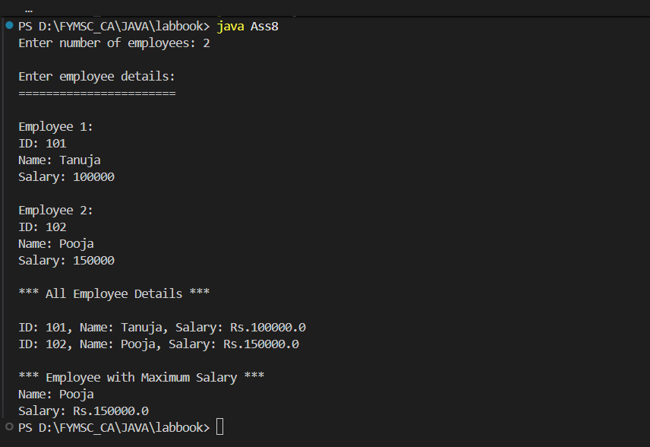

UNIT III: Inheritance, Interface and Package
INHERITANCE
Ass9: Abstract Shape Class - Cylinder
Question: Create an abstract class Shape with methods area & volume. Derive a class Cylinder (radius, height). Calculate area and volume.
Filename: Ass9.java
java
import java.util.Scanner;

abstract class Shape {
abstract void area();
abstract void volume();
}

class Cylinder extends Shape {
double radius, height;
final double PI = 3.142;

Cylinder(double radius, double height) {
this.radius = radius;
this.height = height;
}

void area() {
double area = 2 * PI * radius * (radius + height);
System.out.println("Surface Area of Cylinder: " + area);
}

void volume() {
double volume = PI * radius * radius * height;
System.out.println("Volume of Cylinder: " + volume);
}
}

public class Ass9 {
public static void main(String[] args) {
Scanner sc = new Scanner(System.in);

System.out.println("Enter Cylinder Details:");
System.out.println("=======================");
System.out.print("Enter radius: ");
double radius = sc.nextDouble();
System.out.print("Enter height: ");
double height = sc.nextDouble();

Cylinder cyl = new Cylinder(radius, height);

System.out.println("\nCalculations:");
System.out.println("=============");
cyl.area();
cyl.volume();
}
}
Output:-
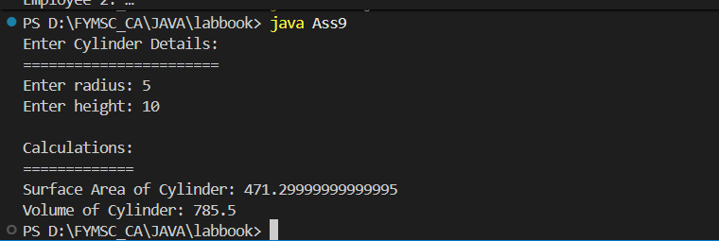

Ass10: Multilevel Inheritance - Employee
Question: Write a Java program to create a super class Employee (members – name, salary). Derive a sub-class as Developer (member – projectname). Derive a sub-class Programmer (member – proglanguage) from Developer. Create object of Programmer and display the details of it. Implement this multilevel inheritance with appropriate constructor and methods.
Filename: Ass10.java
java
import java.util.Scanner;

class Employee {
String name;
double salary;

Employee(String name, double salary) {
this.name = name;
this.salary = salary;
}

void displayEmployee() {
System.out.println("Name: " + name);
System.out.println("Salary: Rs." + salary);
}
}

class Developer extends Employee {
String projectname;

Developer(String name, double salary, String projectname) {
super(name, salary);
this.projectname = projectname;
}

void displayDeveloper() {
displayEmployee();
System.out.println("Project Name: " + projectname);
}
}

class Programmer extends Developer {
String proglanguage;

Programmer(String name, double salary, String projectname, String proglanguage) {
super(name, salary, projectname);
this.proglanguage = proglanguage;
}

void displayProgrammer() {
displayDeveloper();
System.out.println("Programming Language: " + proglanguage);
}
}

public class Ass10 {
public static void main(String[] args) {
Scanner sc = new Scanner(System.in);

System.out.println("Enter Programmer Details:");
System.out.println("=========================");
System.out.print("Enter Name: ");
String name = sc.nextLine();
System.out.print("Enter Salary: ");
double salary = sc.nextDouble();
sc.nextLine();
System.out.print("Enter Project Name: ");
String projectname = sc.nextLine();
System.out.print("Enter Programming Language: ");
String proglanguage = sc.nextLine();

Programmer prog = new Programmer(name, salary, projectname, proglanguage);

System.out.println("\n*** Programmer Details ***");
System.out.println("==========================");
prog.displayProgrammer();
}
}
Output:-
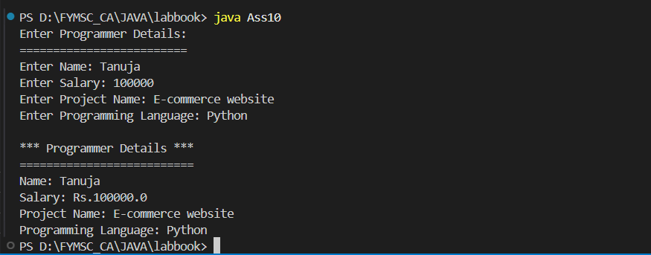
INTERFACE
Ass11: Interface Operation - Circle and Cylinder
Question: Define an interface "Operation" which has methods area(), volume(). Define a constant PI having a value 3.142. Create a class circle (member – radius), cylinder (members – radius, height) which implements this interface. Calculate and display the area and volume.
Filename: Ass11.java
java
import java.util.Scanner;

interface Operation {
double PI = 3.142;
void area();
void volume();
}

class Circle implements Operation {
double radius;

Circle(double radius) {
this.radius = radius;
}

public void area() {
double area = PI * radius * radius;
System.out.println("Area of Circle: " + area);
}

public void volume() {
System.out.println("Volume is not applicable for Circle (2D shape)");
}
}

class Cylinder implements Operation {
double radius, height;

Cylinder(double radius, double height) {
this.radius = radius;
this.height = height;
}

public void area() {
double area = 2 * PI * radius * (radius + height);
System.out.println("Surface Area of Cylinder: " + area);
}

public void volume() {
double volume = PI * radius * radius * height;
System.out.println("Volume of Cylinder: " + volume);
}
}

public class Ass11 {
public static void main(String[] args) {
Scanner sc = new Scanner(System.in);

System.out.println("CIRCLE CALCULATIONS");
System.out.println("===================");
System.out.print("Enter radius of circle: ");
double r1 = sc.nextDouble();

Circle circle = new Circle(r1);
circle.area();
circle.volume();

System.out.println("\nCYLINDER CALCULATIONS");
System.out.println("=====================");
System.out.print("Enter radius of cylinder: ");
double r2 = sc.nextDouble();
System.out.print("Enter height of cylinder: ");
double h = sc.nextDouble();

Cylinder cylinder = new Cylinder(r2, h);
cylinder.area();
cylinder.volume();
}
}
Output:-
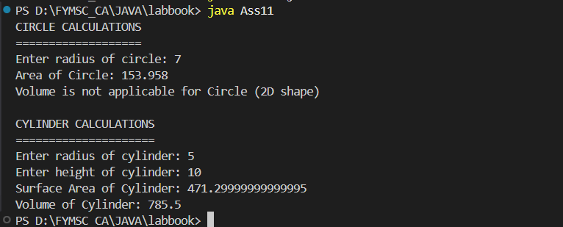

Ass12: Interface Shape - Circle and Sphere
Question: Define an Interface Shape with abstract method area(). Write a java program to calculate an area of Circle and Sphere. (Use final keyword).
Filename: Ass12.java
java
import java.util.Scanner;

interface Shape {
void area();
}

class Circle implements Shape {
final double PI = 3.142;
double radius;

Circle(double radius) {
this.radius = radius;
}

public void area() {
double area = PI * radius * radius;
System.out.println("Area of Circle: " + area);
}
}

class Sphere implements Shape {
final double PI = 3.142;
double radius;

Sphere(double radius) {
this.radius = radius;
}

public void area() {
double area = 4 * PI * radius * radius;
System.out.println("Surface Area of Sphere: " + area);
}
}

public class Ass12 {
public static void main(String[] args) {
Scanner sc = new Scanner(System.in);

System.out.println("CIRCLE AREA CALCULATION");
System.out.println("=======================");
System.out.print("Enter radius of circle: ");
double r1 = sc.nextDouble();

Circle circle = new Circle(r1);
circle.area();

System.out.println("\nSPHERE AREA CALCULATION");
System.out.println("=======================");
System.out.print("Enter radius of sphere: ");
double r2 = sc.nextDouble();

Sphere sphere = new Sphere(r2);
sphere.area();
}
}
Output:-
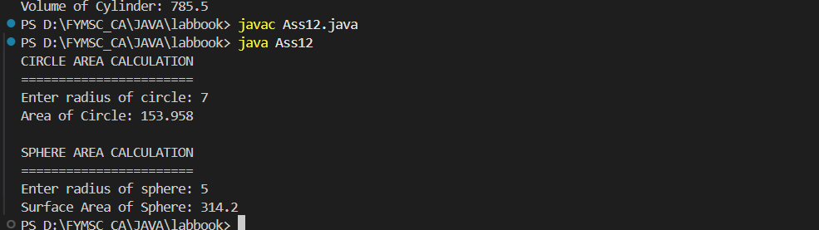
PACKAGES
Ass13: Package Series
Question: Create a package named "Series" having three different classes to print series: a. Fibonacci series b. Cube of numbers c. Square of numbers. Write a java program to generate "n" terms of the above series. Accept n from user.
Step 1: Create Fibonacci.java in Series package Filename: Series/Fibonacci.java
java
package Series;

public class Fibonacci {
public void display(int n) {
int a = 0, b = 1;
System.out.print("Fibonacci Series: ");
for(int i = 0; i < n; i++) {
System.out.print(a + " ");
int next = a + b;
a = b;
b = next;
}
System.out.println();
}
}
Step 2: Create Cube.java in Series package Filename: Series/Cube.java
java
package Series;

public class Cube {
public void display(int n) {
System.out.print("Cube Series: ");
for(int i = 1; i <= n; i++) {
System.out.print((i*i*i) + " ");
}
System.out.println();
}
}
Step 3: Create Square.java in Series package Filename: Series/Square.java
java
package Series;

public class Square {
public void display(int n) {
System.out.print("Square Series: ");
for(int i = 1; i <= n; i++) {
System.out.print((i*i) + " ");
}
System.out.println();
}
}
Step 4: Create main program Filename: Ass13.java
import Series.*;
import java.util.Scanner;

public class Ass13 {
public static void main(String[] args) {
Scanner sc = new Scanner(System.in);

System.out.print("Enter number of terms (n): ");
int n = sc.nextInt();

System.out.println("\nGenerating Series:");
System.out.println("==================");

Fibonacci fib = new Fibonacci();
fib.display(n);

Cube cube = new Cube();
cube.display(n);

Square square = new Square();
square.display(n);
}
}
**Compilation Steps:**
javac -d . Series/Fibonacci.java
javac -d . Series/Cube.java
javac -d . Series/Square.java
javac Ass13.java
java Ass13
Output:-
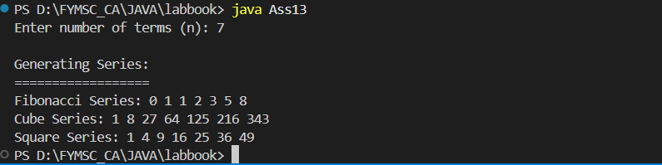

Ass14: Package Game
Question: Write a package game which will have 2 classes Indoor & Outdoor. Use a function display() to generate the list of players for the specific game. Use default & parameterized constructor.
Step 1: Create Indoor.java in game package Filename: game/Indoor.java
java
package game;

public class Indoor {
String gameName;
int numPlayers;

// Default constructor
Indoor() {
this.gameName = "Chess";
this.numPlayers = 2;
}

// Parameterized constructor
Indoor(String gameName, int numPlayers) {
this.gameName = gameName;
this.numPlayers = numPlayers;
}

public void display() {
System.out.println("\n*** Indoor Game Details ***");
System.out.println("Game Name: " + gameName);
System.out.println("Number of Players: " + numPlayers);
System.out.println("List of Players:");
for(int i = 1; i <= numPlayers; i++) {
System.out.println(" Player " + i);
}
}
}
Step 2: Create Outdoor.java in game package Filename: game/Outdoor.java
java
package game;

public class Outdoor {
String gameName;
int numPlayers;

// Default constructor
Outdoor() {
this.gameName = "Cricket";
this.numPlayers = 11;
}

// Parameterized constructor
Outdoor(String gameName, int numPlayers) {
this.gameName = gameName;
this.numPlayers = numPlayers;
}

public void display() {
System.out.println("\n*** Outdoor Game Details ***");
System.out.println("Game Name: " + gameName);
System.out.println("Number of Players: " + numPlayers);
System.out.println("List of Players:");
for(int i = 1; i <= numPlayers; i++) {
System.out.println(" Player " + i);
}
}
}
Step 3: Create main program Filename: Ass14.java
java
import game.*;

public class Ass14 {
public static void main(String[] args) {
// Using default constructor
Indoor indoor1 = new Indoor();
indoor1.display();

// Using parameterized constructor
Indoor indoor2 = new Indoor("Table Tennis", 4);
indoor2.display();

// Using default constructor
Outdoor outdoor1 = new Outdoor();
outdoor1.display();

// Using parameterized constructor
Outdoor outdoor2 = new Outdoor("Football", 11);
outdoor2.display();
}
}
**Compilation Steps:**
```
javac -d . game/Indoor.java
javac -d . game/Outdoor.java
javac Ass14.java
java Ass14
Code:-
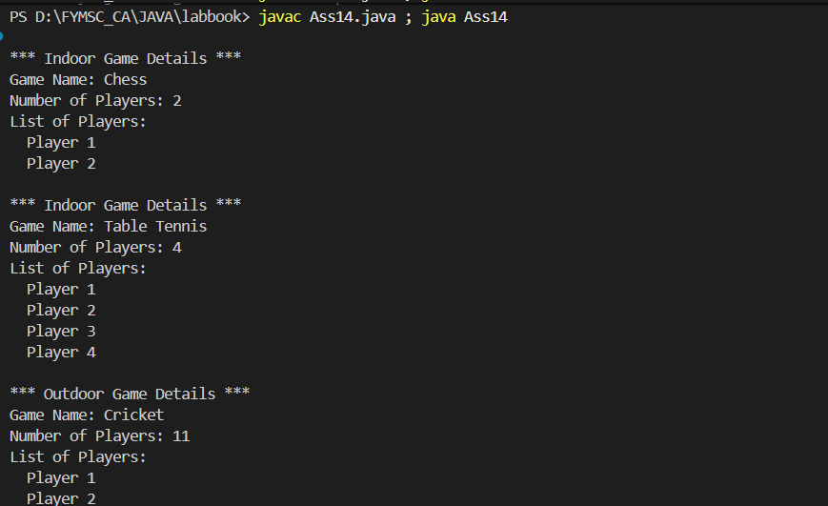
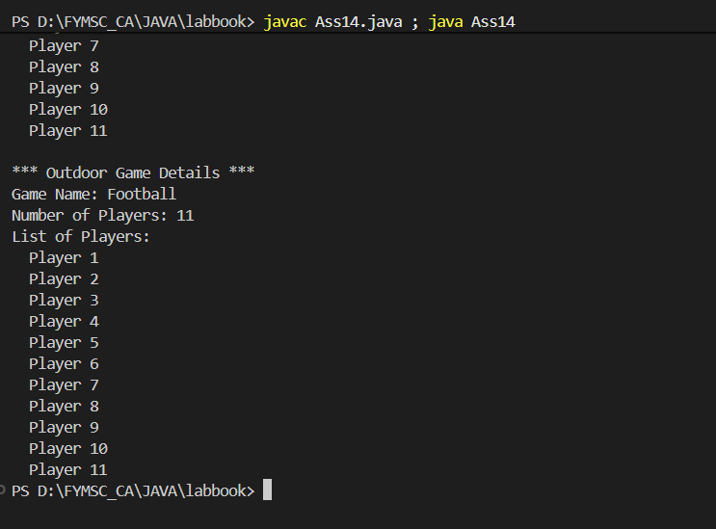

UNIT IV: Collection, Exception Handling and I/O
COLLECTIONS
Ass15: City and STD Codes using HashMap
Question: Create a java application to store city names and their STD codes using an appropriate collection. i. Add a new city and its code (No duplicates) ii. Remove a city from the collection iii. Search for a cityname and display the code.
Filename: Ass15.java
java
import java.util.*;

public class Ass15 {
public static void main(String[] args) {
Scanner sc = new Scanner(System.in);
HashMap<String, String> citySTD = new HashMap<>();

// Initial data
citySTD.put("Mumbai", "022");
citySTD.put("Delhi", "011");
citySTD.put("Bangalore", "080");
citySTD.put("Chennai", "044");
citySTD.put("Kolkata", "033");

while(true) {
System.out.println("\n*** City STD Code Directory ***");
System.out.println("================================");
System.out.println("1. Display all cities and codes");
System.out.println("2. Add a new city and code");
System.out.println("3. Remove a city");
System.out.println("4. Search for a city");
System.out.println("5. Exit");
System.out.print("Enter your choice: ");
int choice = sc.nextInt();
sc.nextLine(); // consume newline

switch(choice) {
case 1:
System.out.println("\nAll Cities and STD Codes:");
System.out.println("-------------------------");
for(Map.Entry<String, String> entry : citySTD.entrySet()) {
System.out.println(entry.getKey() + " : " + entry.getValue());
}
break;

case 2:
System.out.print("Enter city name: ");
String city = sc.nextLine();
if(citySTD.containsKey(city)) {
System.out.println("City already exists with code: " + citySTD.get(city));
} else {
System.out.print("Enter STD code: ");
String code = sc.nextLine();
citySTD.put(city, code);
System.out.println("City added successfully!");
}
break;

case 3:
System.out.print("Enter city name to remove: ");
String removeCity = sc.nextLine();
if(citySTD.containsKey(removeCity)) {
citySTD.remove(removeCity);
System.out.println("City removed successfully!");
} else {
System.out.println("City not found!");
}
break;

case 4:
System.out.print("Enter city name to search: ");
String searchCity = sc.nextLine();
if(citySTD.containsKey(searchCity)) {
System.out.println("STD Code for " + searchCity + " is: " + citySTD.get(searchCity));
} else {
System.out.println("City not found!");
}
break;

case 5:
System.out.println("Exiting... Thank you!");
System.exit(0);

default:
System.out.println("Invalid choice!");
}
}
}
}
Output:-
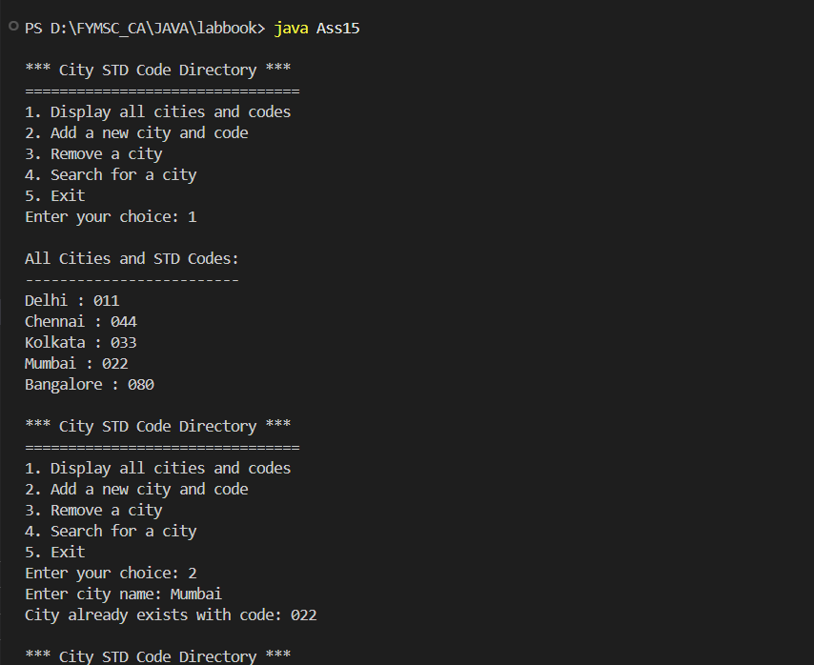
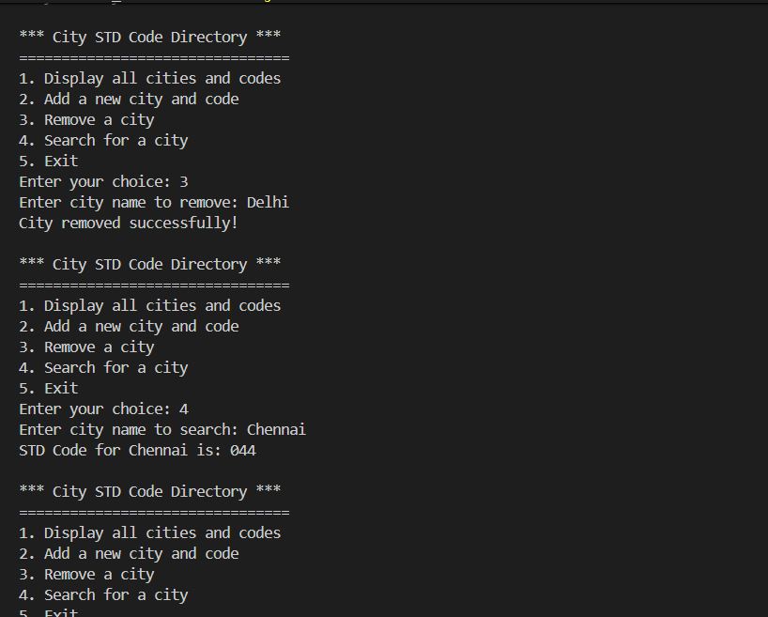
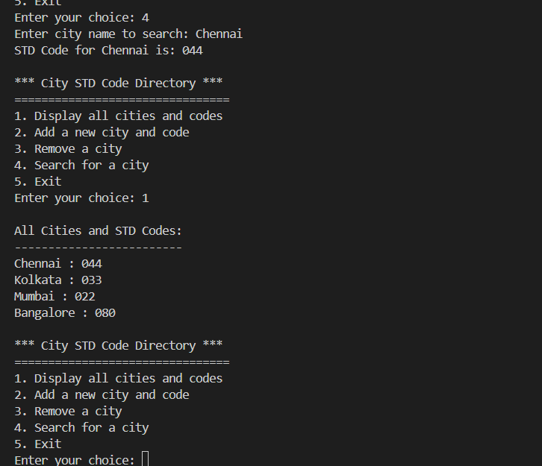
Ass16: LinkedList of Colors
Question: Construct a linked List containing names of colours: red, blue, yellow and orange. Then extend the program to do the following: i. Display the contents of the List using an Iterator ii. Display the contents of the List in reverse order using a ListIterator iii. Create another list containing pink and green. Insert the elements of this list between blue and yellow.
Filename: Ass16.java
java
import java.util.*;

public class Ass16 {
public static void main(String[] args) {
// Create LinkedList with initial colors
LinkedList<String> colors = new LinkedList<>();
colors.add("Red");
colors.add("Blue");
colors.add("Yellow");
colors.add("Orange");

System.out.println("*** LinkedList Operations ***\n");

// i. Display using Iterator
System.out.println("1. Display contents using Iterator:");
System.out.println("------------------------------------");
Iterator<String> iterator = colors.iterator();
while(iterator.hasNext()) {
System.out.println(iterator.next());
}

// ii. Display in reverse order using ListIterator
System.out.println("\n2. Display contents in reverse order:");
System.out.println("--------------------------------------");
ListIterator<String> listIterator = colors.listIterator(colors.size());
while(listIterator.hasPrevious()) {
System.out.println(listIterator.previous());
}

// iii. Create another list and insert between Blue and Yellow
LinkedList<String> newColors = new LinkedList<>();
newColors.add("Pink");
newColors.add("Green");

System.out.println("\n3. Insert Pink and Green between Blue and Yellow:");
System.out.println("--------------------------------------------------");

int index = colors.indexOf("Yellow");
colors.addAll(index, newColors);

System.out.println("Updated List:");
for(String color : colors) {
System.out.println(color);
}
}
}
Output:-
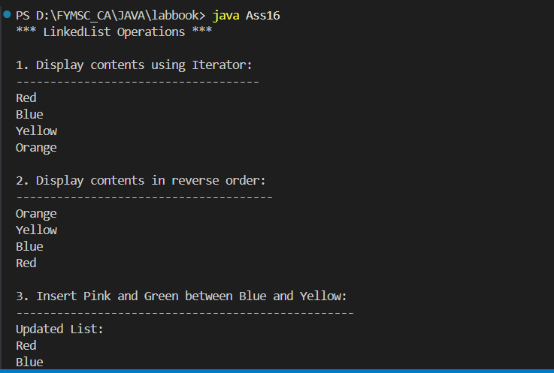
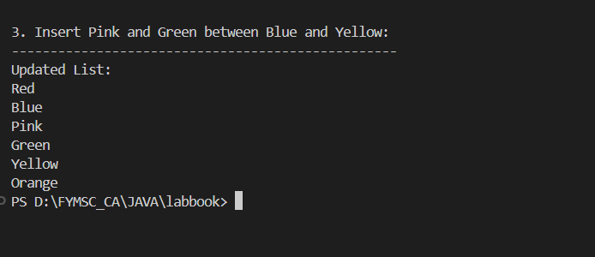

EXCEPTION HANDLING
Ass17: Student Exception Handling
Question: Write a class Student with attributes roll no, name, age and course. Initialize values through parameterized constructor. If age of student is not in between 15 and 21 then generate user-defined exception "Age Not Within The Range". If name contains numbers or special symbols raise exception "Name not valid".
Filename: Ass17.java
java
import java.util.Scanner;

class AgeNotWithinRangeException extends Exception {
AgeNotWithinRangeException(String message) {
super(message);
}
}

class NameNotValidException extends Exception {
NameNotValidException(String message) {
super(message);
}
}

class Student {
int rollno;
String name;
int age;
String course;

Student(int rollno, String name, int age, String course) throws AgeNotWithinRangeException, NameNotValidException {
// Validate age
if(age < 15 || age > 21) {
throw new AgeNotWithinRangeException("Age Not Within The Range (15-21)");
}

// Validate name
if(!name.matches("[a-zA-Z ]+")) {
throw new NameNotValidException("Name not valid - Contains numbers or special symbols");
}

this.rollno = rollno;
this.name = name;
this.age = age;
this.course = course;
}

void display() {
System.out.println("\n*** Student Details ***");
System.out.println("Roll No: " + rollno);
System.out.println("Name: " + name);
System.out.println("Age: " + age);
System.out.println("Course: " + course);
}
}

public class Ass17 {
public static void main(String[] args) {
Scanner sc = new Scanner(System.in);

try {
System.out.println("Enter Student Details:");
System.out.println("======================");
System.out.print("Roll No: ");
int rollno = sc.nextInt();
sc.nextLine();
System.out.print("Name: ");
String name = sc.nextLine();
System.out.print("Age: ");
int age = sc.nextInt();
sc.nextLine();
System.out.print("Course: ");
String course = sc.nextLine();

Student student = new Student(rollno, name, age, course);
student.display();
System.out.println("\nStudent created successfully!");

} catch(AgeNotWithinRangeException e) {
System.out.println("\nException: " + e.getMessage());
} catch(NameNotValidException e) {
System.out.println("\nException: " + e.getMessage());
}
}
}
Output:-
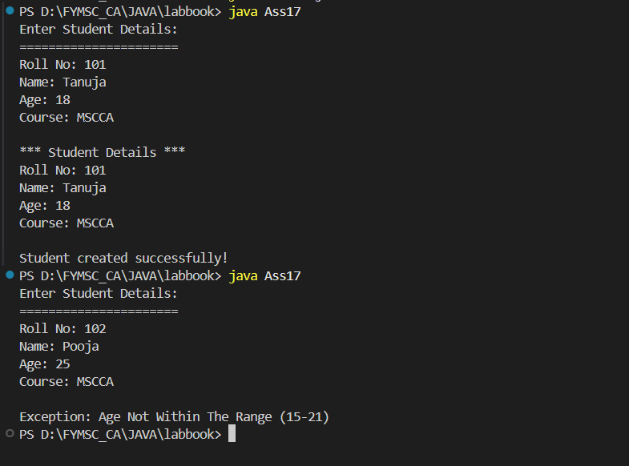

Ass18: MyDate Exception Handling
Question: Define a class MyDate (day, month, year) with methods to accept and display a MyDate object. Accept date as dd, mm, yyyy. Throw user defined exception "InvalidDateException" if the date is invalid. Examples of invalid dates: 12 15 2015, 31 6 1990, 29 2 2001.
Filename: Ass18.java
java
import java.util.Scanner;

class InvalidDateException extends Exception {
InvalidDateException(String message) {
super(message);
}
}

class MyDate {
int day, month, year;

MyDate(int day, int month, int year) throws InvalidDateException {
// Validate month
if(month < 1 || month > 12) {
throw new InvalidDateException("Invalid month: " + month);
}

// Days in each month
int[] daysInMonth = {0, 31, 28, 31, 30, 31, 30, 31, 31, 30, 31, 30, 31};

// Check for leap year
if(isLeapYear(year)) {
daysInMonth[2] = 29;
}

// Validate day
if(day < 1 || day > daysInMonth[month]) {
throw new InvalidDateException("Invalid day: " + day + " for month: " + month);
}

this.day = day;
this.month = month;
this.year = year;
}

boolean isLeapYear(int year) {
return (year % 4 == 0 && year % 100 != 0) || (year % 400 == 0);
}

void display() {
System.out.println("\n*** Valid Date ***");
System.out.println("Date: " + day + "/" + month + "/" + year);
}
}

public class Ass18 {
public static void main(String[] args) {
Scanner sc = new Scanner(System.in);

try {
System.out.println("Enter Date:");
System.out.println("===========");
System.out.print("Day (dd): ");
int day = sc.nextInt();
System.out.print("Month (mm): ");
int month = sc.nextInt();
System.out.print("Year (yyyy): ");
int year = sc.nextInt();

MyDate date = new MyDate(day, month, year);
date.display();

} catch(InvalidDateException e) {
System.out.println("\nInvalidDateException: " + e.getMessage());
}
}
}
Output:-
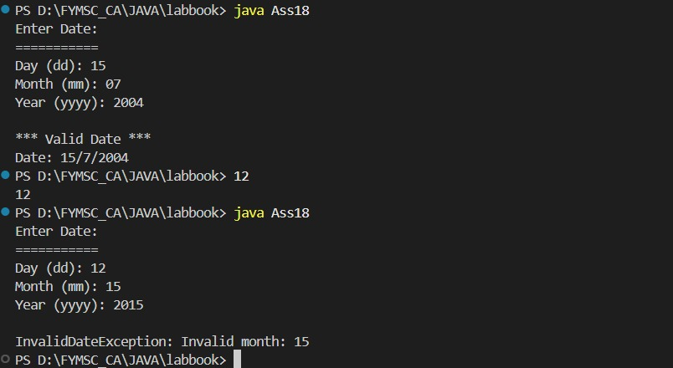
I/O OPERATIONS
Ass19: File Operations with DataInputStream/DataOutputStream
Question: Write a java program to accept details of n customers (c_id, cname, address, mobile_no) from user and store it in a file (Use DataOutputStream class). Display the details of customers by reading it from file. (Use DataInputStream class).
Filename: Ass19.java
java
import java.io.*;
import java.util.Scanner;

class Customer {
int c_id;
String cname;
String address;
String mobile_no;

Customer(int c_id, String cname, String address, String mobile_no) {
this.c_id = c_id;
this.cname = cname;
this.address = address;
this.mobile_no = mobile_no;
}
}

public class Ass19 {
public static void main(String[] args) {
Scanner sc = new Scanner(System.in);

try {
System.out.print("Enter number of customers: ");
int n = sc.nextInt();
sc.nextLine();

// Write to file
DataOutputStream dos = new DataOutputStream(new FileOutputStream("customers.dat"));

System.out.println("\nEnter Customer Details:");
System.out.println("=======================");

for(int i = 0; i < n; i++) {
System.out.println("\nCustomer " + (i+1) + ":");
System.out.print("Customer ID: ");
int c_id = sc.nextInt();
sc.nextLine();
System.out.print("Customer Name: ");
String cname = sc.nextLine();
System.out.print("Address: ");
String address = sc.nextLine();
System.out.print("Mobile No: ");
String mobile_no = sc.nextLine();

dos.writeInt(c_id);
dos.writeUTF(cname);
dos.writeUTF(address);
dos.writeUTF(mobile_no);
}

dos.close();
System.out.println("\nCustomer details saved to file successfully!");

// Read from file
DataInputStream dis = new DataInputStream(new FileInputStream("customers.dat"));

System.out.println("\n*** Customer Details from File ***");
System.out.println("===================================");

try {
for(int i = 0; i < n; i++) {
System.out.println("\nCustomer " + (i+1) + ":");
System.out.println("Customer ID: " + dis.readInt());
System.out.println("Customer Name: " + dis.readUTF());
System.out.println("Address: " + dis.readUTF());
System.out.println("Mobile No: " + dis.readUTF());
System.out.println("-----------------------------");
}
} catch(EOFException e) {
// End of file reached
}

dis.close();

} catch(IOException e) {
System.out.println("Error: " + e.getMessage());
}
}
}
Output:-
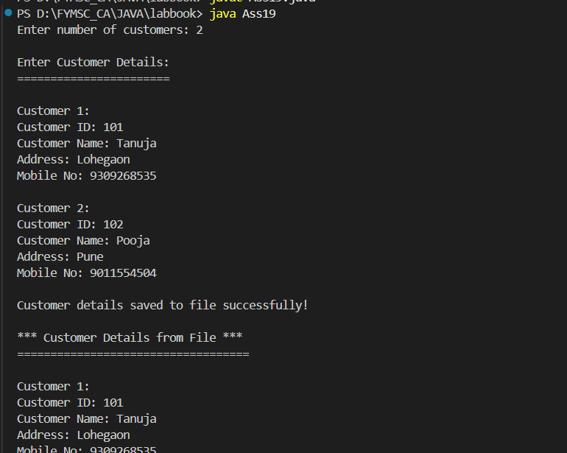

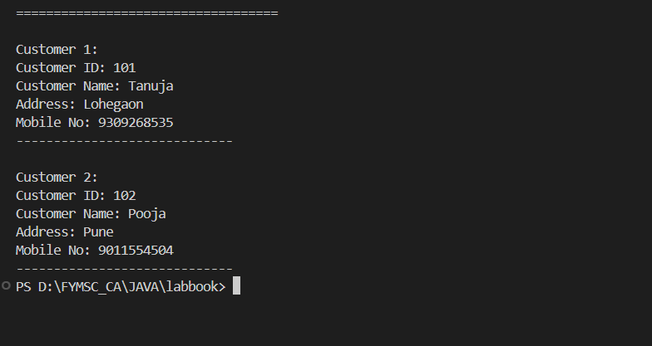

Ass20: Read File and Convert to Uppercase
Question: Write a program to read the contents of "abc.txt" file. Display the contents of file in uppercase as output.

First, create a text file named abc.txt with some content:
**File: abc.txt**
```
Hello World
This is a Java Programming Lab
Welcome to File Handling
Learning Java is Fun
Filename: Ass20.java
java
import java.io.*;

public class Ass20 {
public static void main(String[] args) {
try {
// Create abc.txt file with sample content (for demonstration)
FileWriter fw = new FileWriter("abc.txt");
fw.write("Hello World\n");
fw.write("This is a Java Programming Lab\n");
fw.write("Welcome to File Handling\n");
fw.write("Learning Java is Fun\n");
fw.close();
System.out.println("File 'abc.txt' created successfully!\n");

// Read from file
FileReader fr = new FileReader("abc.txt");
BufferedReader br = new BufferedReader(fr);

System.out.println("*** Original File Contents ***");
System.out.println("==============================");

String line;
StringBuilder originalContent = new StringBuilder();

while((line = br.readLine()) != null) {
System.out.println(line);
originalContent.append(line).append("\n");
}

br.close();

// Display in uppercase
System.out.println("\n*** File Contents in UPPERCASE ***");
System.out.println("===================================");
System.out.println(originalContent.toString().toUpperCase());

} catch(IOException e) {
System.out.println("Error: " + e.getMessage());
}
}
}
Output:-
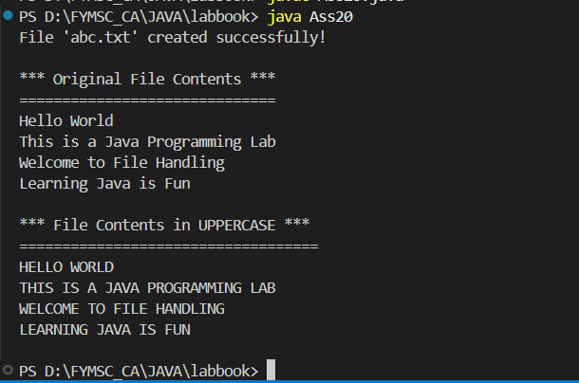

UNIT V: Swing
Ass21: JComboBox with JLabel
Question: Write a Program to design following GUI by using swing component JComboBox. On click of show button display the selected language on JLabel.
Filename: Ass21.java
java
import javax.swing.*;
import java.awt.*;
import java.awt.event.*;

public class Ass21 extends JFrame implements ActionListener {
JComboBox<String> languageCombo;
JButton showButton;
JLabel resultLabel;

public Ass21() {
setTitle("Language Selection");
setSize(400, 250);
setDefaultCloseOperation(JFrame.EXIT_ON_CLOSE);
setLayout(new FlowLayout());

// Create components
JLabel heading = new JLabel("Select a Programming Language:");
heading.setFont(new Font("Arial", Font.BOLD, 16));

String[] languages = {"Java", "Python", "C++", "JavaScript", "C#", "Ruby", "PHP"};
languageCombo = new JComboBox<>(languages);
languageCombo.setPreferredSize(new Dimension(200, 30));

showButton = new JButton("Show Selected Language");
showButton.addActionListener(this);

resultLabel = new JLabel("");
resultLabel.setFont(new Font("Arial", Font.BOLD, 14));
resultLabel.setForeground(Color.BLUE);

// Add components
add(heading);
add(languageCombo);
add(showButton);
add(resultLabel);

setVisible(true);
}

public void actionPerformed(ActionEvent e) {
if(e.getSource() == showButton) {
String selected = (String) languageCombo.getSelectedItem();
resultLabel.setText("You selected: " + selected);
}
}

public static void main(String[] args) {
new Ass21();
}
}
Output:-
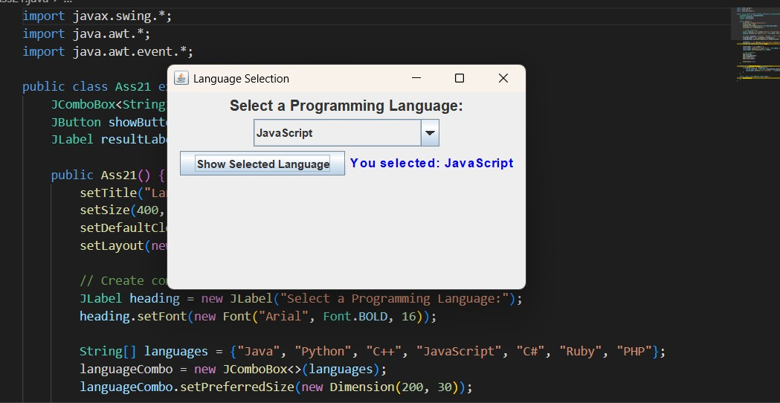
Question 2: Write a java program to design a following GUI. Use appropriate Layout and Components.
java
// Ass22.java
// Question: Write a java program to design a following GUI. Use appropriate Layout and Components.
// This program creates a GUI with BorderLayout containing a menu bar, toolbar, text area, and status bar

import javax.swing.*;
import java.awt.*;
import java.awt.event.*;

public class Ass22 extends JFrame {
private JTextArea textArea;
private JLabel statusLabel;

public Ass22() {
setTitle("GUI Design - Assignment 2");
setSize(600, 400);
setDefaultCloseOperation(JFrame.EXIT_ON_CLOSE);
setLayout(new BorderLayout());

// Create Menu Bar
JMenuBar menuBar = new JMenuBar();
JMenu fileMenu = new JMenu("File");
JMenu editMenu = new JMenu("Edit");
JMenu helpMenu = new JMenu("Help");

JMenuItem newItem = new JMenuItem("New");
JMenuItem openItem = new JMenuItem("Open");
JMenuItem saveItem = new JMenuItem("Save");
JMenuItem exitItem = new JMenuItem("Exit");
exitItem.addActionListener(e -> System.exit(0));

fileMenu.add(newItem);
fileMenu.add(openItem);
fileMenu.add(saveItem);
fileMenu.addSeparator();
fileMenu.add(exitItem);

menuBar.add(fileMenu);
menuBar.add(editMenu);
menuBar.add(helpMenu);
setJMenuBar(menuBar);

// Create Toolbar
JToolBar toolBar = new JToolBar();
JButton newBtn = new JButton("New");
JButton openBtn = new JButton("Open");
JButton saveBtn = new JButton("Save");
toolBar.add(newBtn);
toolBar.add(openBtn);
toolBar.add(saveBtn);
add(toolBar, BorderLayout.NORTH);

// Create Text Area
textArea = new JTextArea();
JScrollPane scrollPane = new JScrollPane(textArea);
add(scrollPane, BorderLayout.CENTER);

// Create Status Bar
statusLabel = new JLabel("Ready");
statusLabel.setBorder(BorderFactory.createEtchedBorder());
add(statusLabel, BorderLayout.SOUTH);

setVisible(true);
}

public static void main(String[] args) {
SwingUtilities.invokeLater(() -> new Ass22());
}
}
Output:-
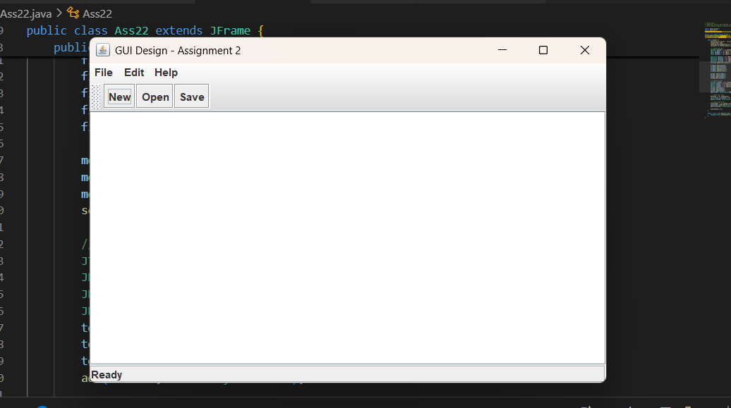

Question 3: Write a java program to design a following GUI. Use appropriate Layout and Components.
java
// Ass23.java
// Question: Write a java program to design a following GUI. Use appropriate Layout and Components.
// This program creates a registration form GUI using GridBagLayout with various components

import javax.swing.*;
import java.awt.*;
import java.awt.event.*;

public class Ass23 extends JFrame {
private JTextField nameField, emailField, phoneField;
private JRadioButton maleRadio, femaleRadio;
private JComboBox<String> countryCombo;
private JCheckBox termsCheck;
private JTextArea addressArea;

public Ass23() {
setTitle("Registration Form - Assignment 3");
setSize(500, 500);
setDefaultCloseOperation(JFrame.EXIT_ON_CLOSE);
setLayout(new BorderLayout());

// Main Panel with GridBagLayout
JPanel mainPanel = new JPanel(new GridBagLayout());
GridBagConstraints gbc = new GridBagConstraints();
gbc.insets = new Insets(5, 5, 5, 5);
gbc.fill = GridBagConstraints.HORIZONTAL;

// Title
JLabel titleLabel = new JLabel("Registration Form", JLabel.CENTER);
titleLabel.setFont(new Font("Arial", Font.BOLD, 18));
gbc.gridx = 0;
gbc.gridy = 0;
gbc.gridwidth = 2;
mainPanel.add(titleLabel, gbc);

gbc.gridwidth = 1;

// Name
gbc.gridx = 0;
gbc.gridy = 1;
mainPanel.add(new JLabel("Name:"), gbc);
gbc.gridx = 1;
nameField = new JTextField(20);
mainPanel.add(nameField, gbc);

// Email
gbc.gridx = 0;
gbc.gridy = 2;
mainPanel.add(new JLabel("Email:"), gbc);
gbc.gridx = 1;
emailField = new JTextField(20);
mainPanel.add(emailField, gbc);

// Phone
gbc.gridx = 0;
gbc.gridy = 3;
mainPanel.add(new JLabel("Phone:"), gbc);
gbc.gridx = 1;
phoneField = new JTextField(20);
mainPanel.add(phoneField, gbc);

// Gender
gbc.gridx = 0;
gbc.gridy = 4;
mainPanel.add(new JLabel("Gender:"), gbc);
gbc.gridx = 1;
JPanel genderPanel = new JPanel(new FlowLayout(FlowLayout.LEFT));
maleRadio = new JRadioButton("Male");
femaleRadio = new JRadioButton("Female");
ButtonGroup genderGroup = new ButtonGroup();
genderGroup.add(maleRadio);
genderGroup.add(femaleRadio);
genderPanel.add(maleRadio);
genderPanel.add(femaleRadio);
mainPanel.add(genderPanel, gbc);

// Country
gbc.gridx = 0;
gbc.gridy = 5;
mainPanel.add(new JLabel("Country:"), gbc);
gbc.gridx = 1;
String[] countries = {"Select Country", "India", "USA", "UK", "Canada", "Australia"};
countryCombo = new JComboBox<>(countries);
mainPanel.add(countryCombo, gbc);

// Address
gbc.gridx = 0;
gbc.gridy = 6;
mainPanel.add(new JLabel("Address:"), gbc);
gbc.gridx = 1;
addressArea = new JTextArea(4, 20);
JScrollPane scrollPane = new JScrollPane(addressArea);
mainPanel.add(scrollPane, gbc);

// Terms and Conditions
gbc.gridx = 0;
gbc.gridy = 7;
gbc.gridwidth = 2;
termsCheck = new JCheckBox("I agree to terms and conditions");
mainPanel.add(termsCheck, gbc);

// Buttons
gbc.gridy = 8;
JPanel buttonPanel = new JPanel(new FlowLayout());
JButton submitBtn = new JButton("Submit");
JButton resetBtn = new JButton("Reset");

submitBtn.addActionListener(e -> submitForm());
resetBtn.addActionListener(e -> resetForm());

buttonPanel.add(submitBtn);
buttonPanel.add(resetBtn);
mainPanel.add(buttonPanel, gbc);

add(mainPanel, BorderLayout.CENTER);
setVisible(true);
}

private void submitForm() {
if (nameField.getText().isEmpty() || emailField.getText().isEmpty()) {
JOptionPane.showMessageDialog(this, "Please fill all required fields!",
"Error", JOptionPane.ERROR_MESSAGE);
return;
}
if (!termsCheck.isSelected()) {
JOptionPane.showMessageDialog(this, "Please accept terms and conditions!",
"Error", JOptionPane.WARNING_MESSAGE);
return;
}
JOptionPane.showMessageDialog(this, "Registration Successful!",
"Success", JOptionPane.INFORMATION_MESSAGE);
}

private void resetForm() {
nameField.setText("");
emailField.setText("");
phoneField.setText("");
addressArea.setText("");
maleRadio.setSelected(false);
femaleRadio.setSelected(false);
countryCombo.setSelectedIndex(0);
termsCheck.setSelected(false);
}

public static void main(String[] args) {
SwingUtilities.invokeLater(() -> new Ass23());
}
}
Output:-
